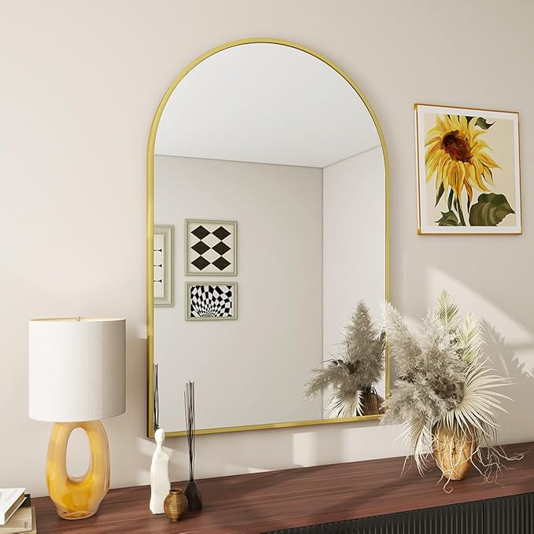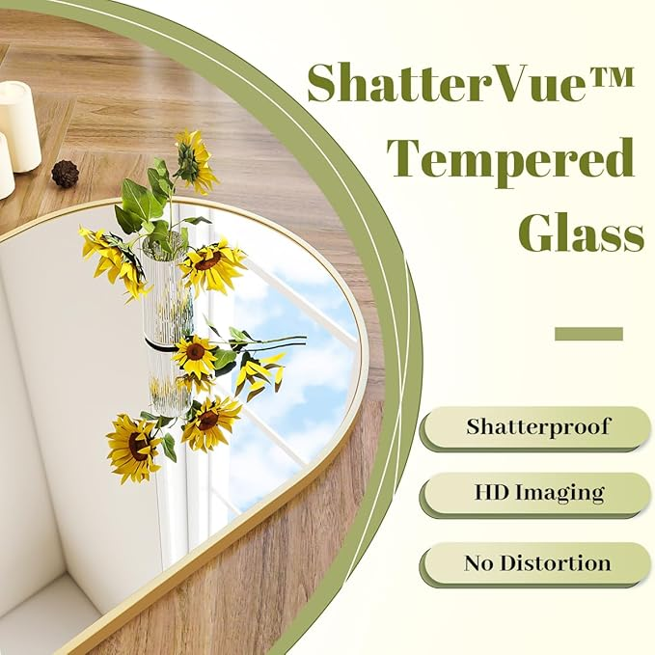

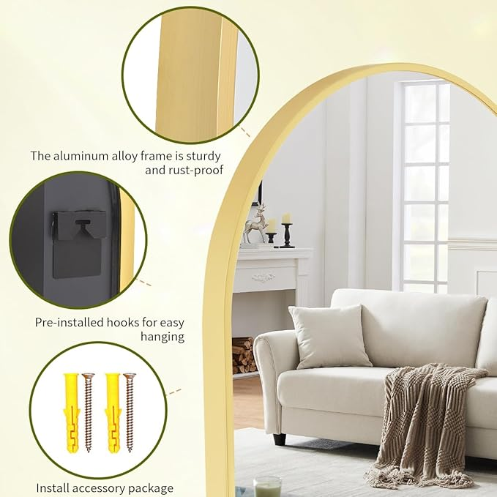

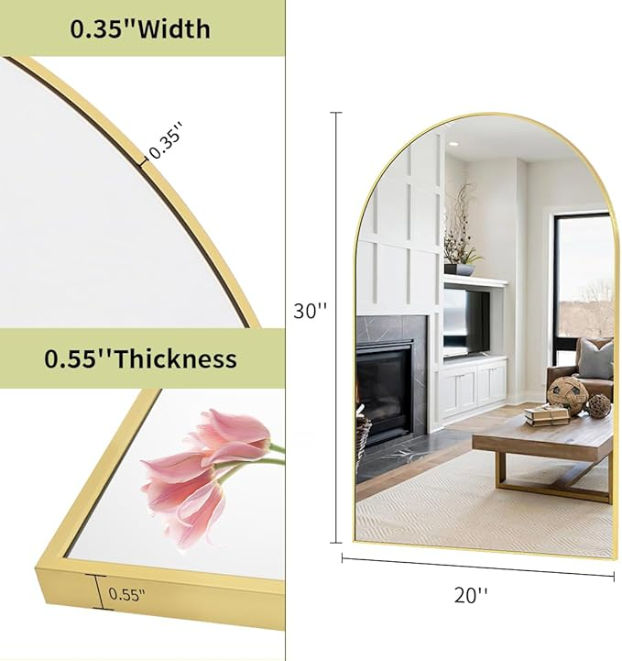

BEAUTYPEAK 20"x30" Arch Bathroom Mirror, Wall Mounted Vanity Metal Frame Mirror for Bedroom, Entryway, Living Room, Gold

**PRODUCT DESCRIPTION:**

|  |  |
| --- | --- |
| **Brand** | BEAUTYPEAK |
| **Room Type** | Bathroom, Dressing, Bedroom, Living,Dining Room |
| **Shape** | Arched Top |
| **Product Dimensions** | 30"L x 20"W |
| **Frame Material** | Aluminum |

**About this item**

* ARCHED CROWN SHAPE: Arch mirror brings old-world charm to any room, decorative mirror makes a great way to add vertical space and draws your eyes, perfect for making your space feel brighter and more open
* BRUSHED METAL FRAME: The aluminum alloy frame is sturdy and rust-proof. Special anti-corrosion mirror treatment, designed for a long time use
* HD MIRROR: Made of shatter-proof glass, the wall mounted mirror provides a crystal-clear, distortion-free reflection, so you can appreciate your true beauty in the vanity mirror
* APPLICATION: Used as a vanity mirror or a decorative mirror in your bedroom, living room, bathroom, gallery wall, entryway, salons even shops. A wonderful addition to capture guests' attention and get more compliments
* 100% SATISFACTION: If the wall mirror is damaged when it arrives, or you don't absolutely love our product, please contact us in time and we'll offer you 24/7 attentive customer service